**LOADING SEMI STRUCTURED DATA**

**Semi Structured Data:**

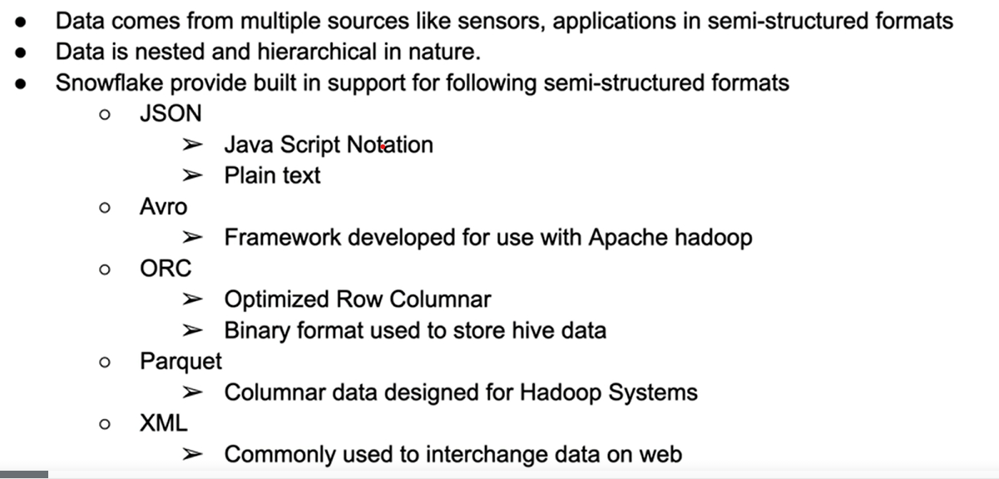

**Data Types to support semi –structured data:**

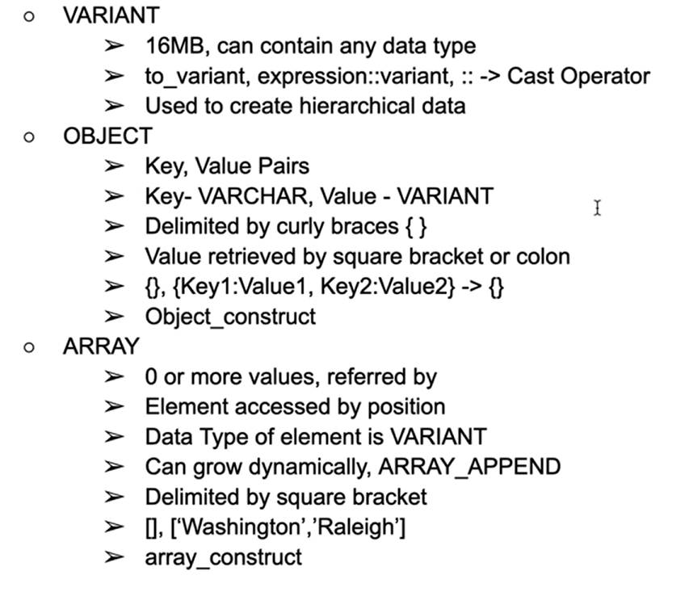

Let’s do some hands on in snowflake:

Plain text data

You get an organized tabular format when you give a key & value pair like the below:

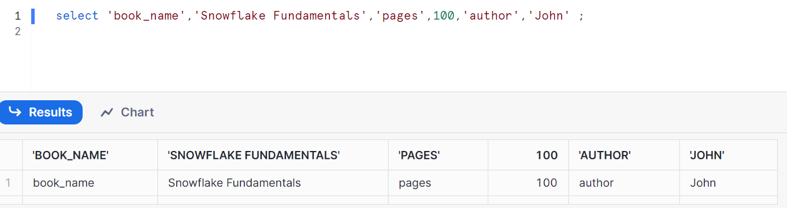

Constructs:

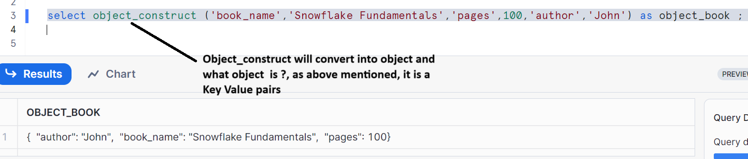

Let’s create a table for object

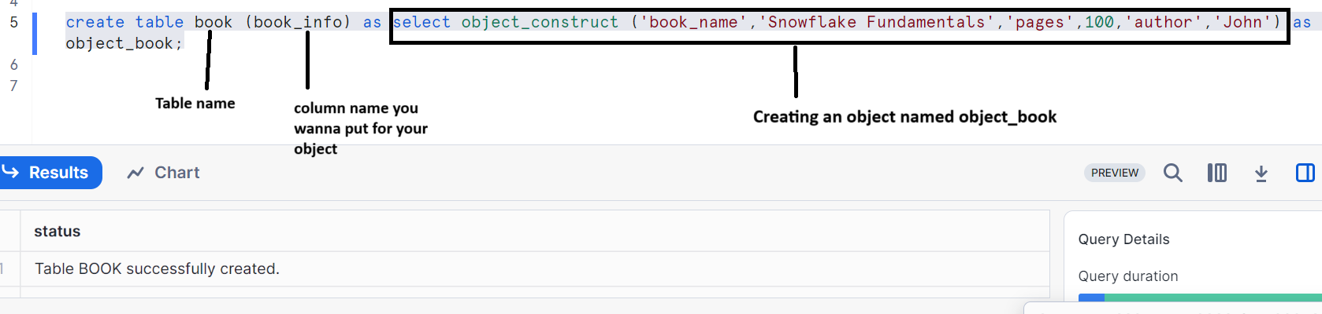

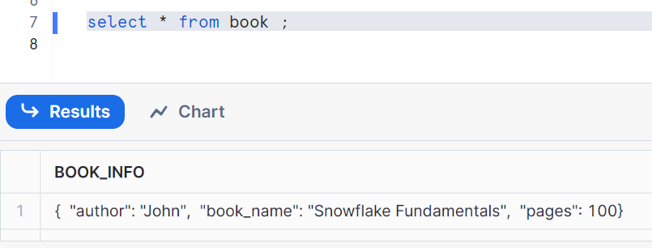

From your column name in your table, pick whatever you want pick from your object

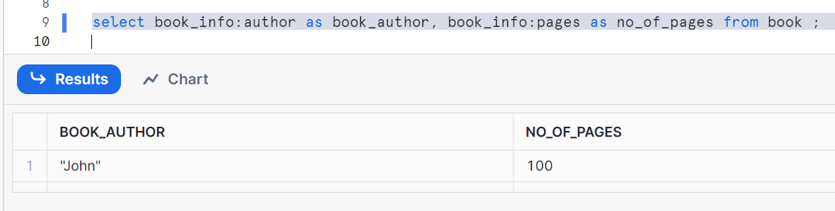

As we can see above that john is coming in double quotes. Hence in order to remove, we convert into string

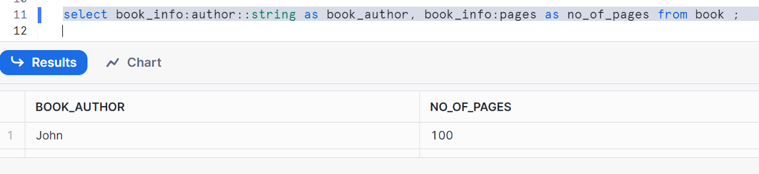

Let’s do the same for Arrays with an example

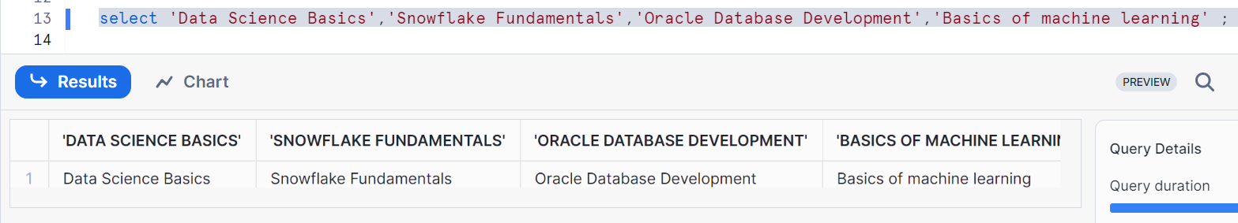

Array_construct will convert into array (list of elements)

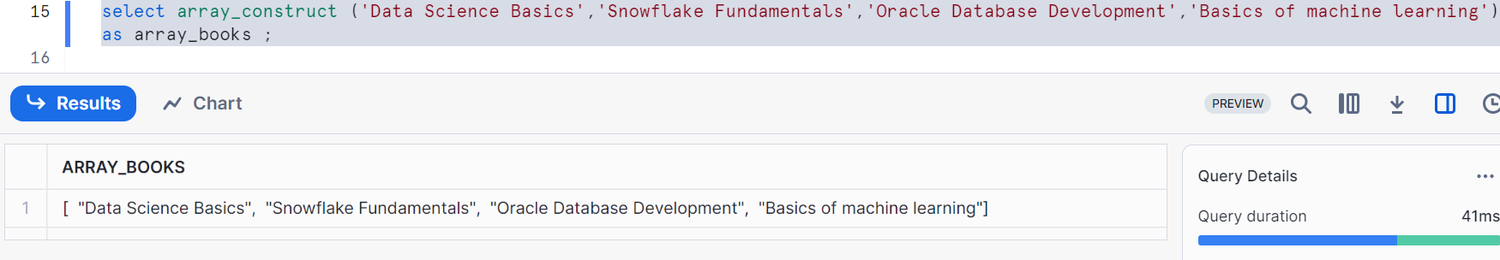

Creating a table

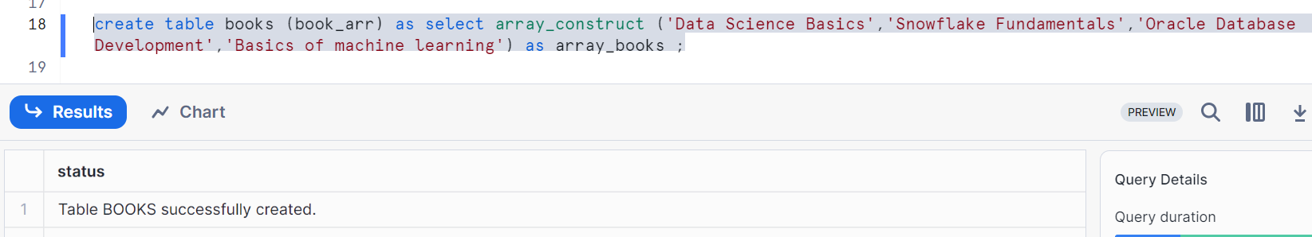

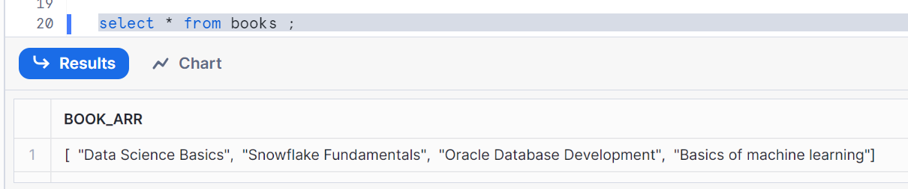

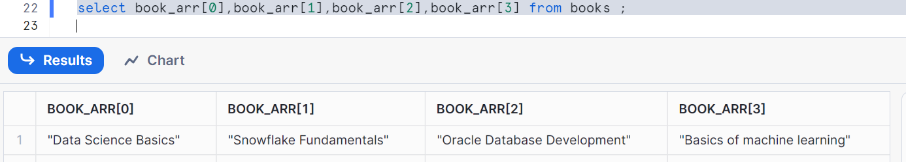

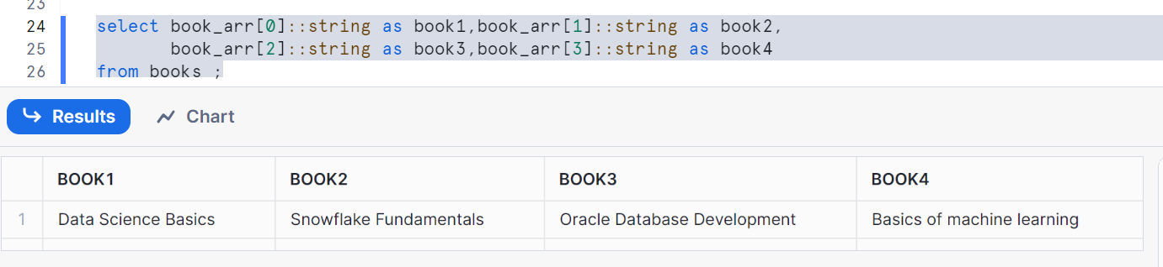

Cleanup:

Drop table book;

Drop table books;

**When we deal with semi-structured data loading, we have to do following**

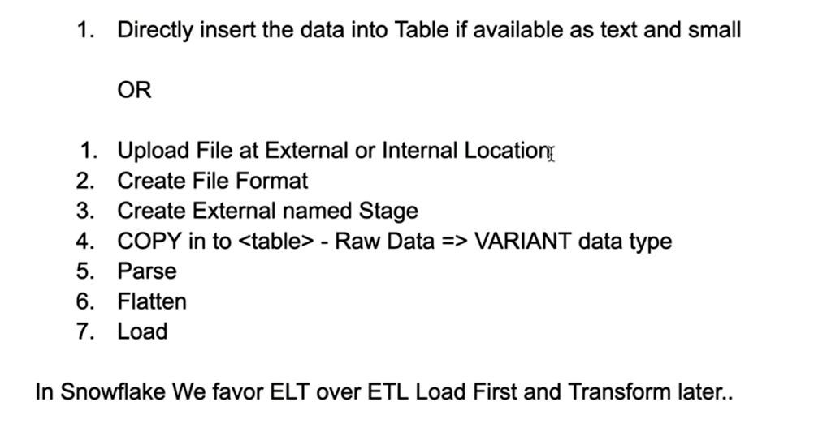

Let’s do hands on

First let us check the JSON data

Here is my data file named book.json

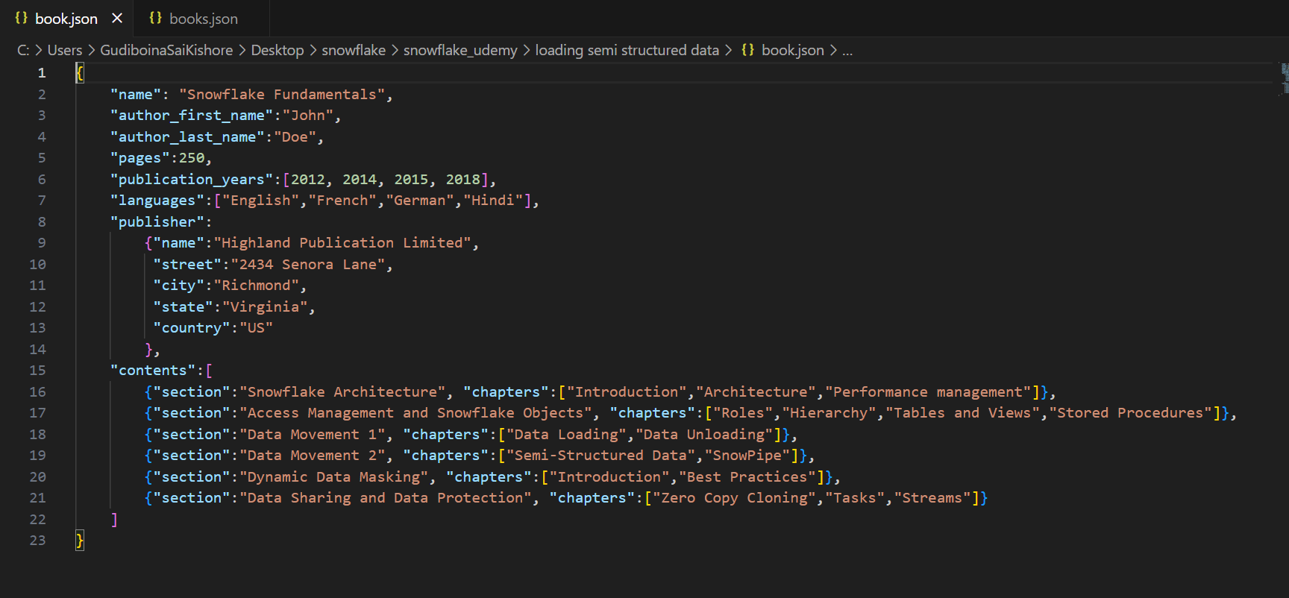

Create table to load the **JSON text data (note: as we are doing it manually for JSON text data to load)**

Src is a column name with the data type variant

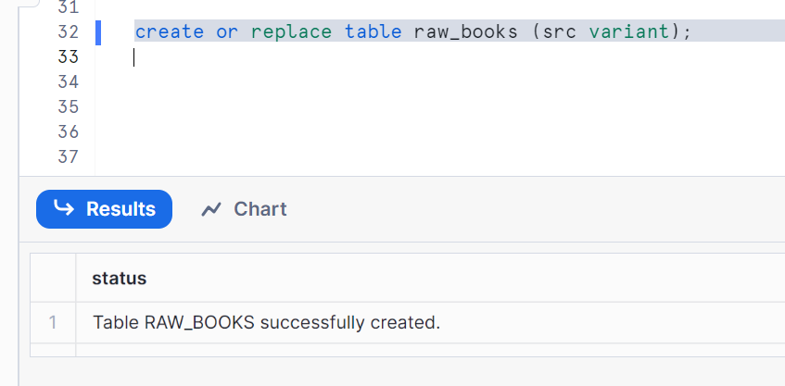

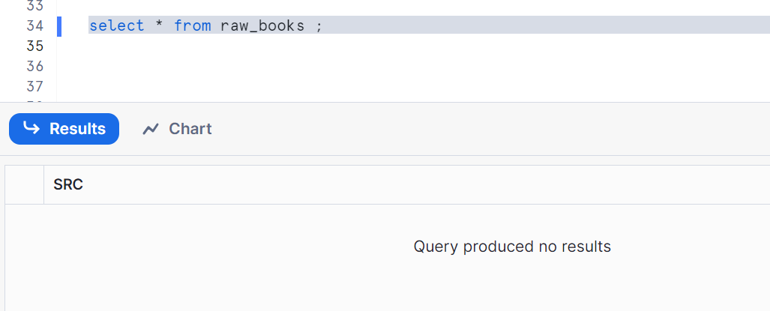

Insert data using parse_json

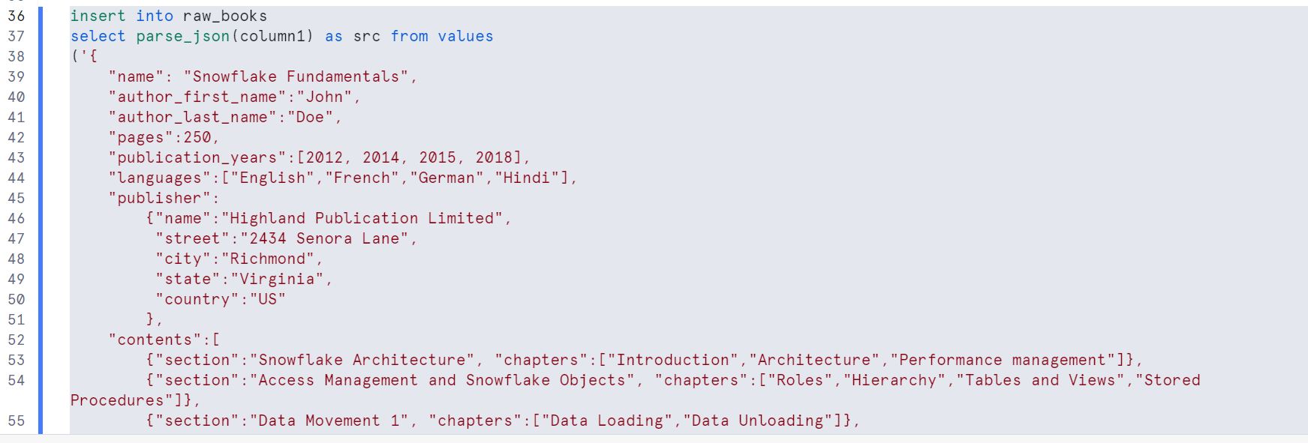

Field names will be in sorted order as you see in below image

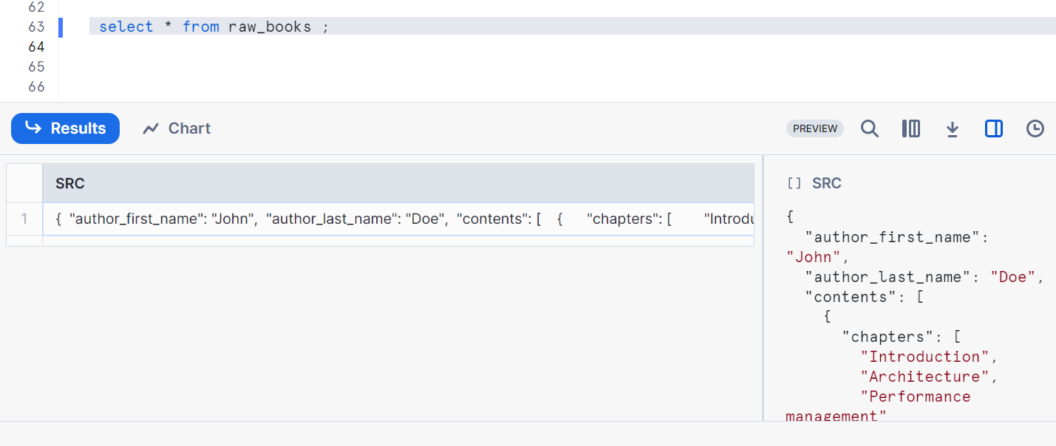

Now let’s see how to load json file data from external location

Create an external file location i.e. in AWS

Please refer latest post snowflake_23 (I explained it in detail)

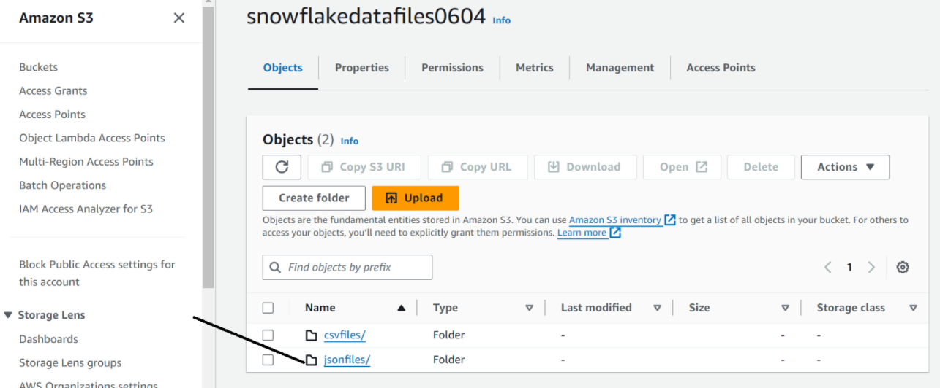

Create a folder dataload in it and add files in it

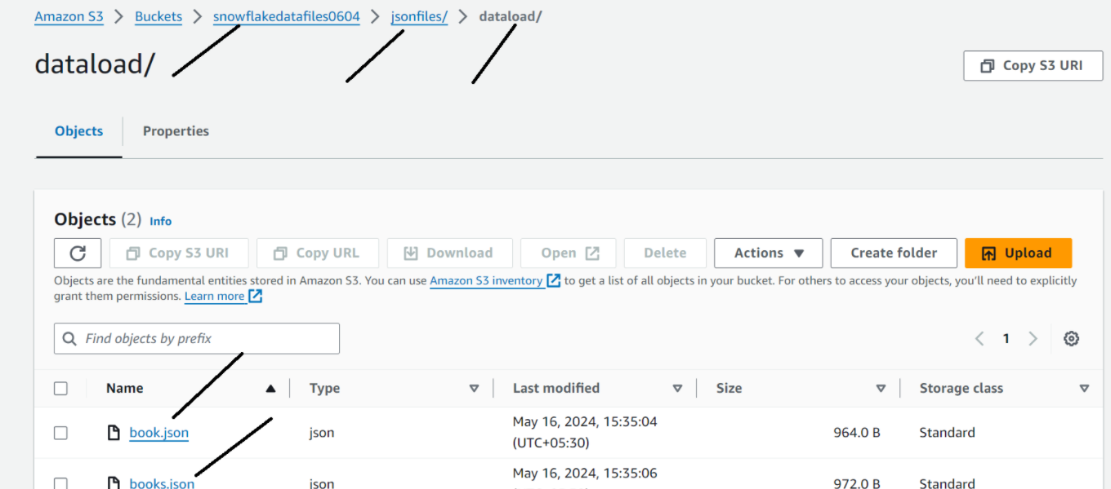

Create integration object

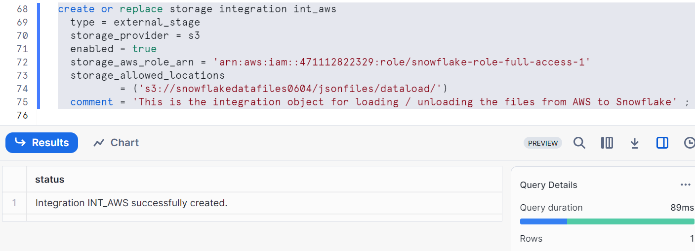

Creating file format

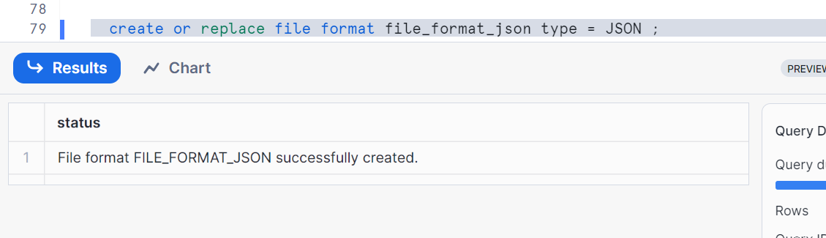

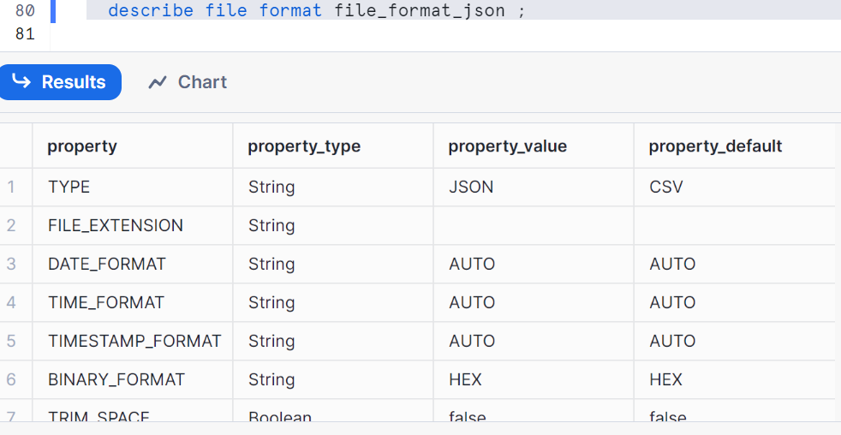

Create external stage for loading data

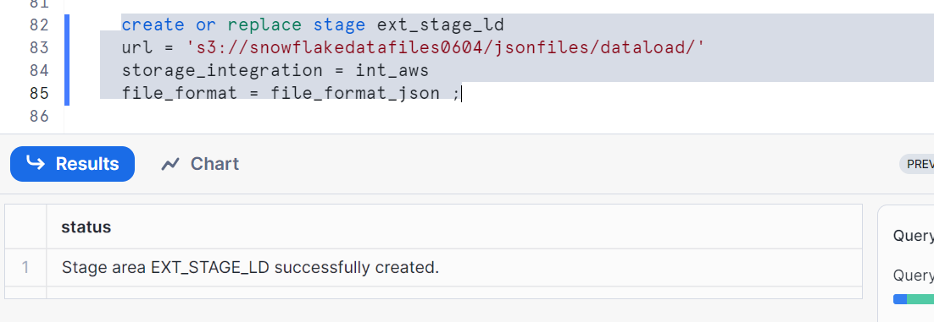

In AWS, edit the trust policy in your IAMrole

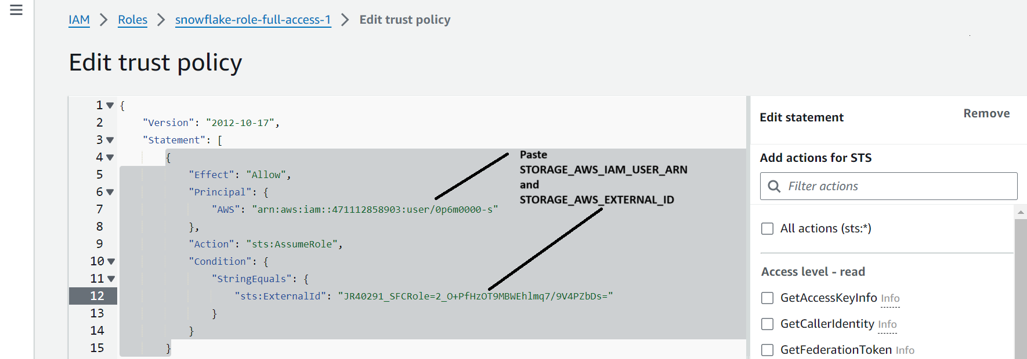

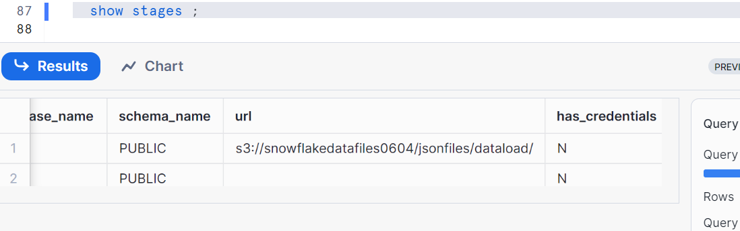

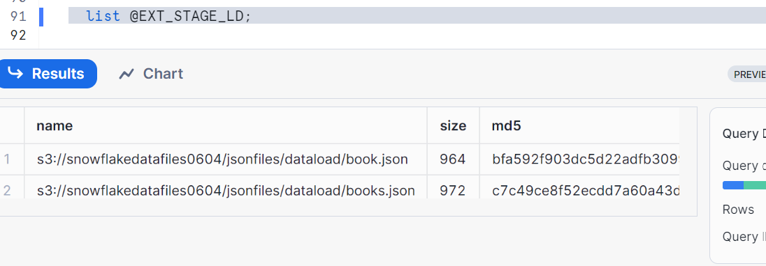

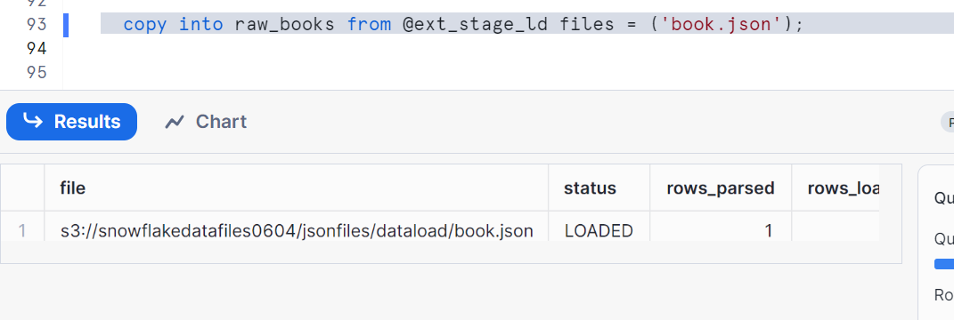

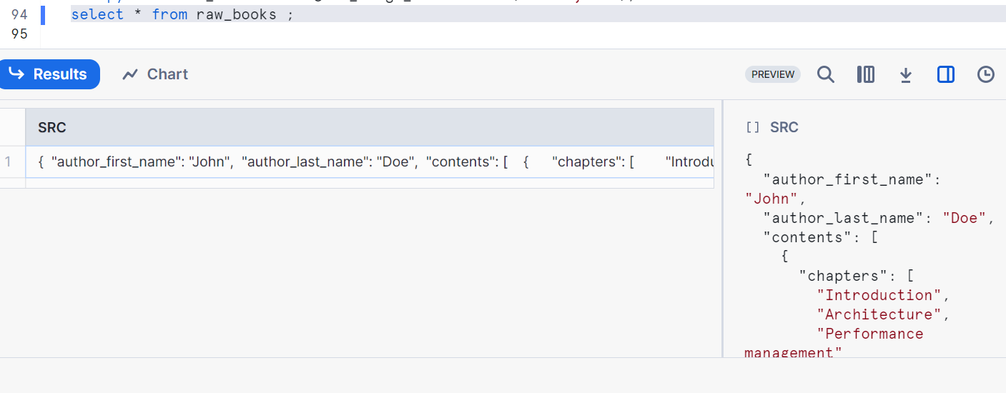

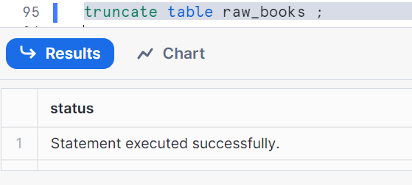

Parsing the JSON data

Select specific columns

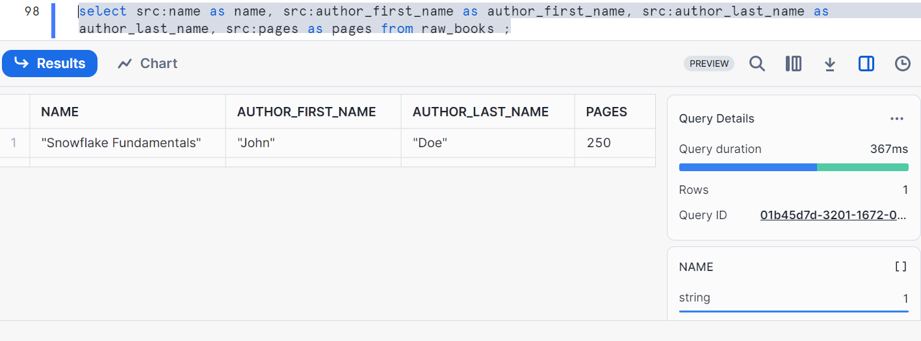

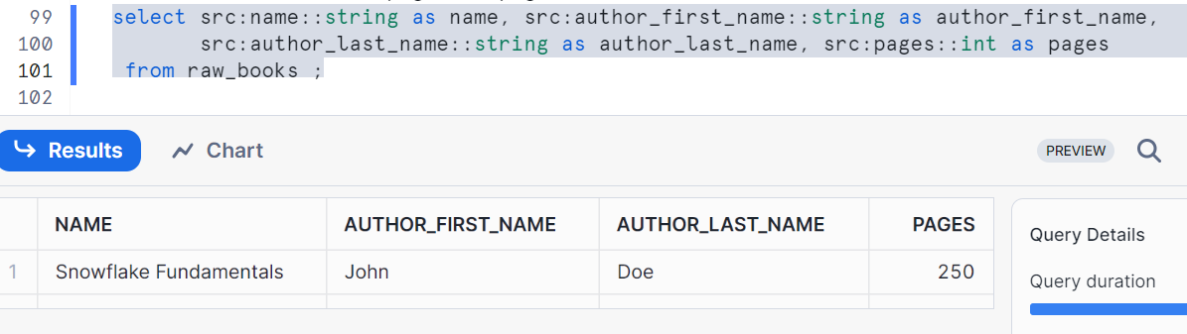

Handling Array - selecting the string array and number array

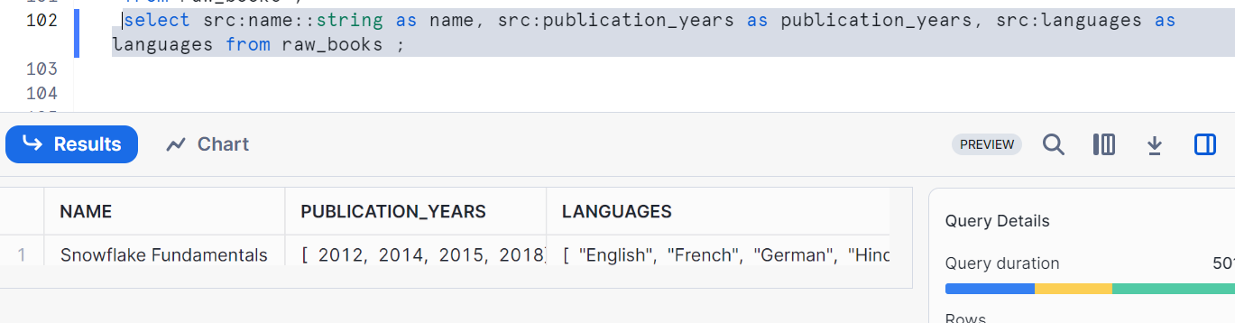

Selecting first element of Array

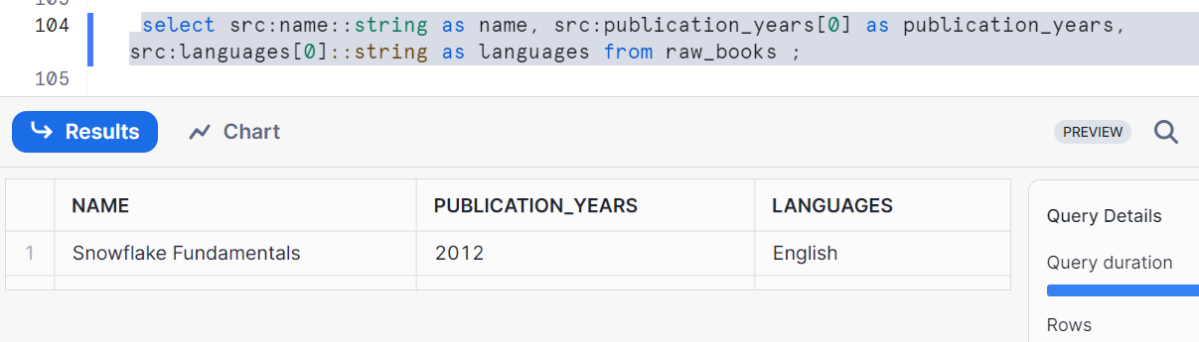

ARRAY_SIZE - to check the length of array and do operations traversing in loop

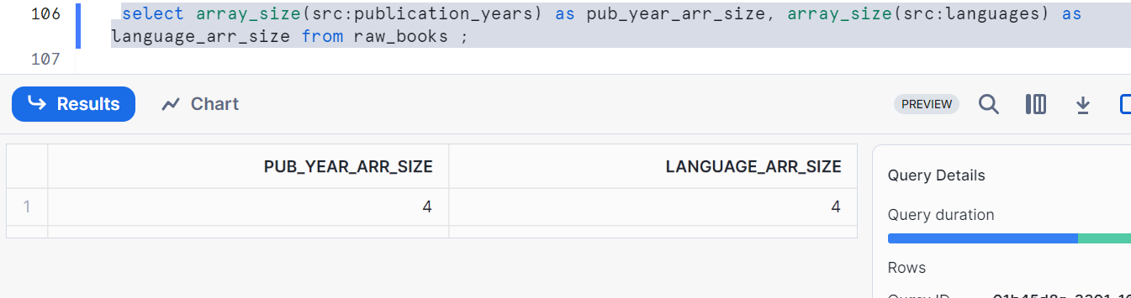

**Flatten function in snowflake:**

It explodes the compound values into the multiple rows and it has been provided by snowflake to handle the semi structured data

It accepts variant, object and array column and produces a lateral view

Used for converting semi-structured to relational data

Input is expression -> can be object, array or variant. This will be converted to rows and will be a mandatory parameter

Output is - (sequence, key, path, index, value,this) i.e. (Generated number, key of exploded expression, path of the element, index if array, value, element)

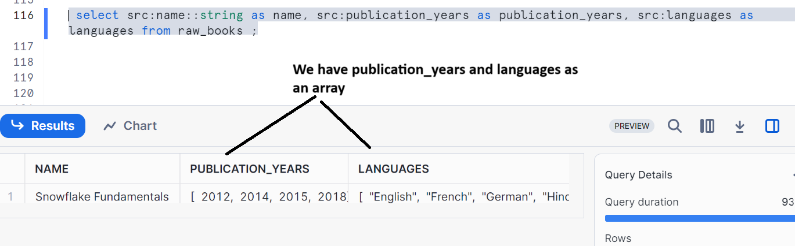

Now let’s see the example of publication_years by using flatten function

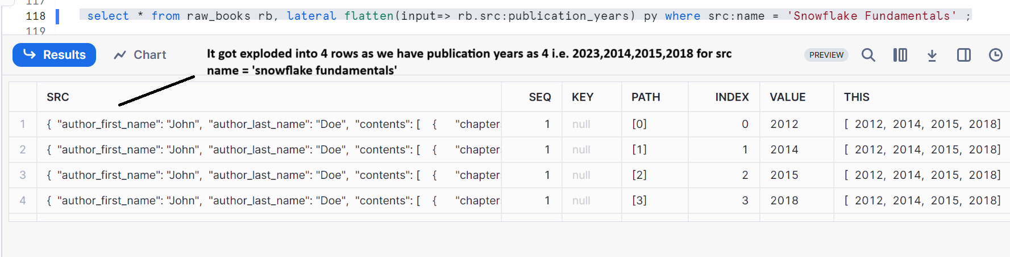

Now let’s pass object into flatten function and observe

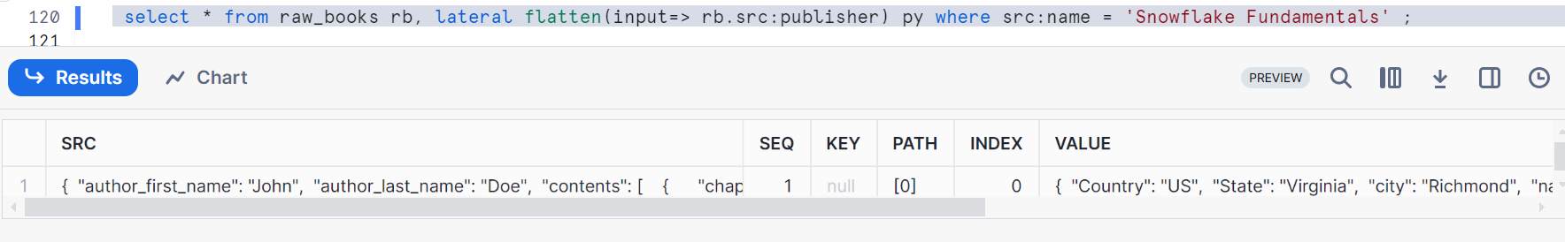

Now let’s pass variant into flatten function and observe

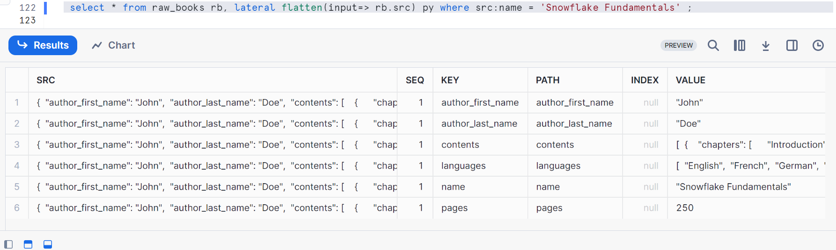

Now let’s load all the Json data into table format in snowflake

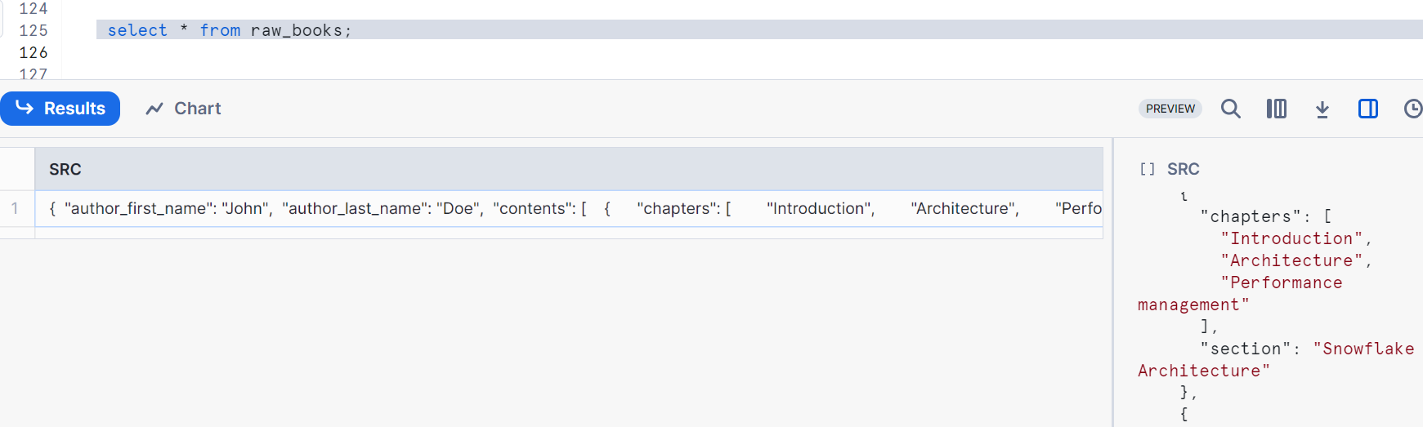

As it is not possible to show the complete output, I am showing the file data again which table raw_books contains

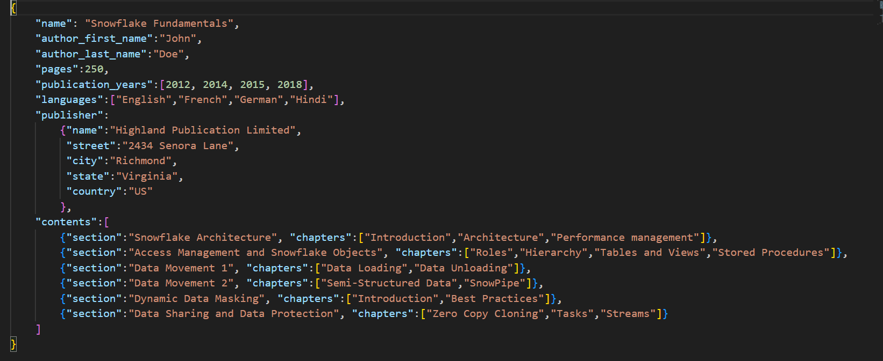

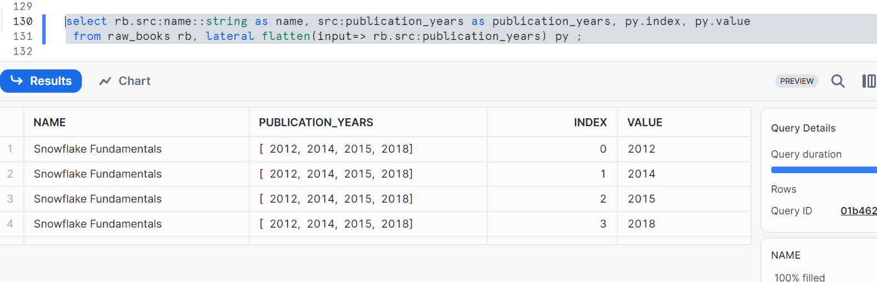

You can use as table as well if you want

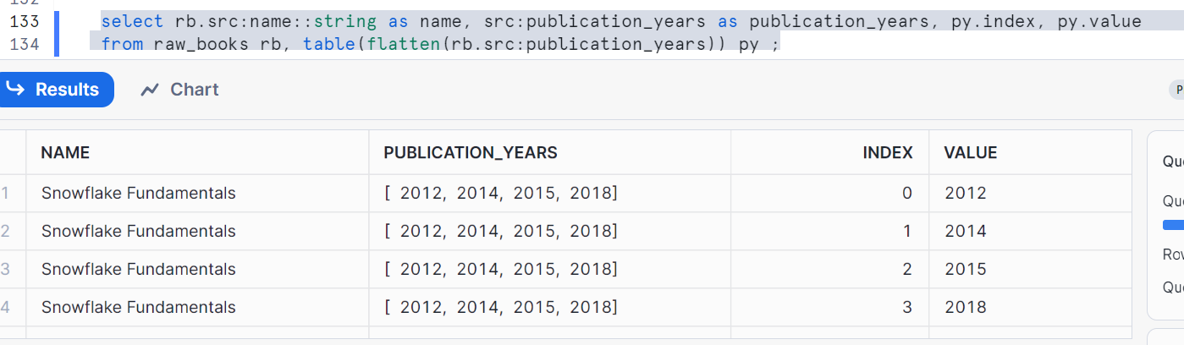

Now let’s write the syntax to convert entire JSON data into table, please follow step by step & understand it with respect to input JSON data

Run it in SF

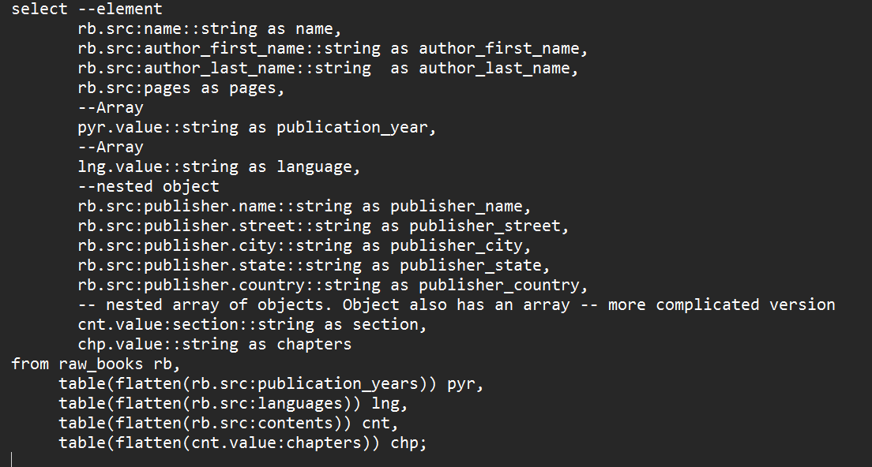

The output is as follows where I had downloaded the output in Snowflake and opened in excel to show you

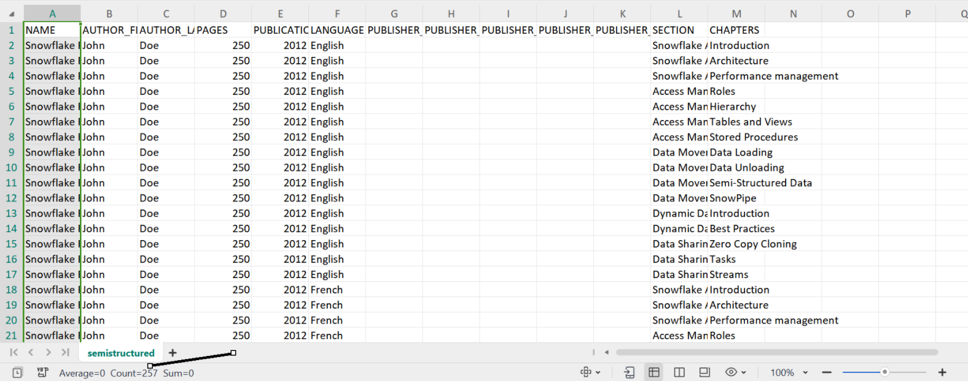

Therefore entire Json is been converted to tabular format in snowflake with appropriate column names

Now lets create a table by using the above query

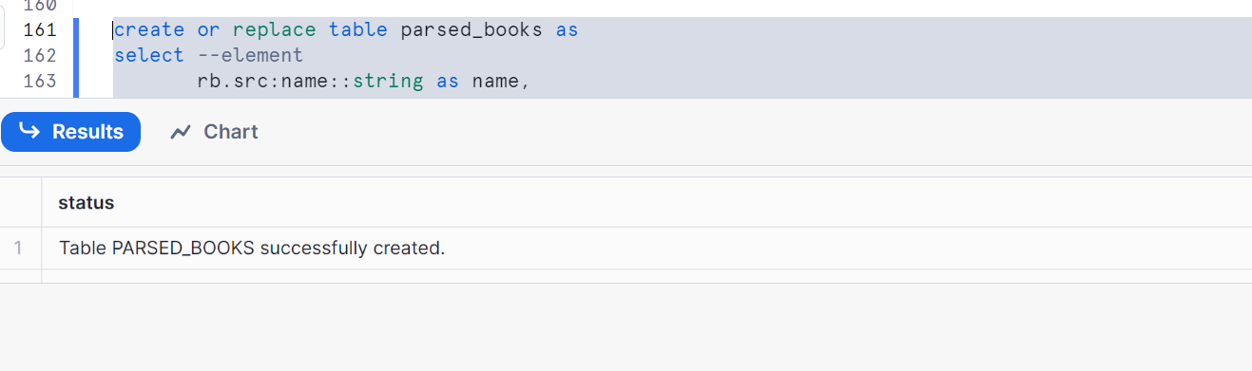

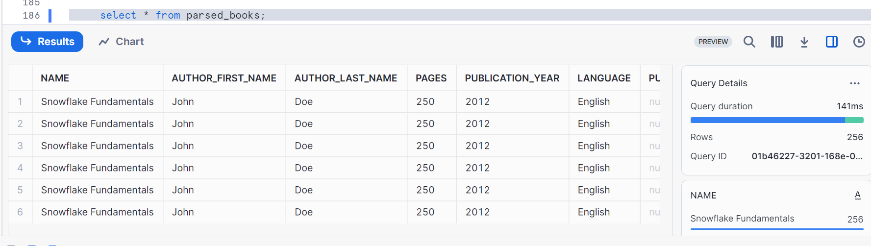

Now query as you wanted

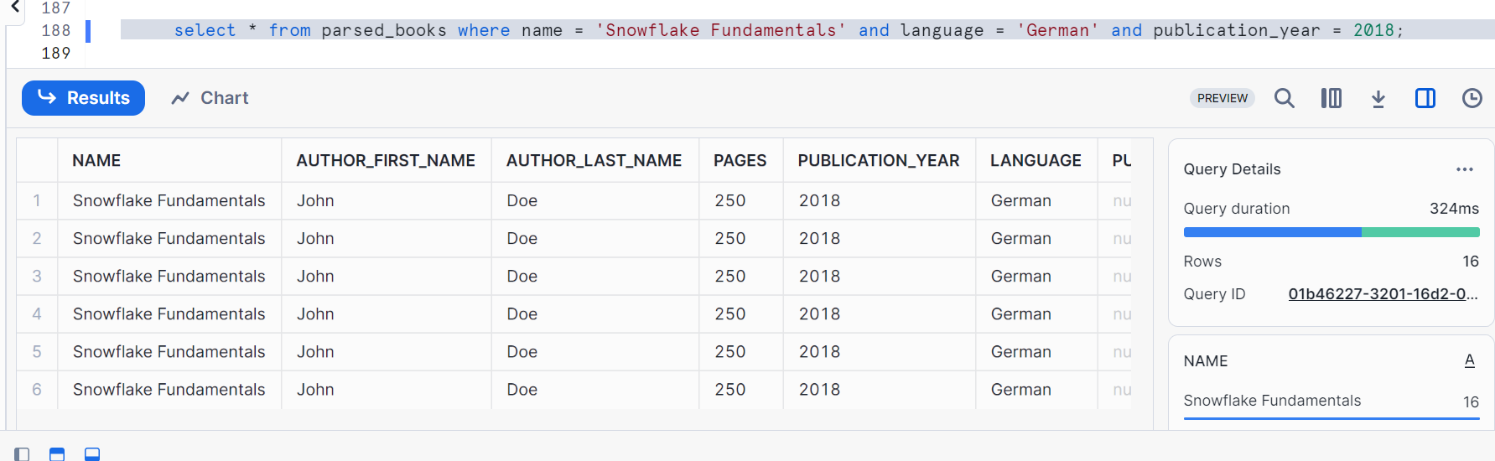

Clean up:

Drop table raw_books;

Drop table parsed_books;

Drop stage ext_stage_ld;

Drop storage integration int_aws;

Drop file format file_format_json;